**SYNCHRONOUS MOTOR**

**REPORT**

* **STARTUP PROCESS:**

When a synchronous motor is started, the excitation DC voltage is not applied to the field winding. The motor is started in induction machine mode with current induced in the damper and field windings. A resistor is connected across the field windings in order to produce an acceptable field current and to limit voltage induced across the field winding. Then when the speed reaches a present value near synchronous speed, the field winding is connected to the DC voltage source and the motor synchronizes on the system frequency. The circuit model for simulation is as follows:

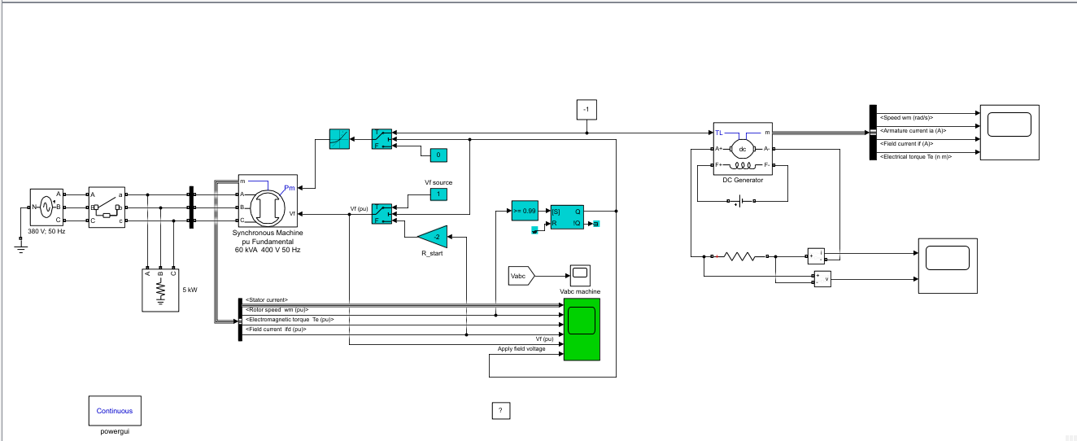

The results, conclusions etc. are discussed below.

* **MOTOR SPEED:**

Synchronous motor runs at constant speed. The synchronous speed of motor depends upon the supply frequency of the motor and no of poles of the motor. The speed is given by:

$$N_{s}= \frac{120f}{p}$$

We can change this speed of motor by changing the supply frequency of motor but the motor would always run with this speed for a given supply frequency and number of poles. Here in my project, at start, the rotor speed of motor is 0wm and it gradually increases to its maximum speed i.e. 1wm and continues to be constant at 1wm. The below graph confirms the claim:

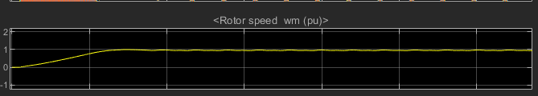

This graph is the simulation of my project in starting the synchronous motor. However it does fluctuate between 1-0.9wm.

* **ACTIVE AND REACTIVE POWER:**

When the rotor of synchronous motor is overexcited i.e. given more DC excitation, when the grid is lagging and in need of a reactive power, it would provide the needed reactive power to the grid but when the rotor of motor is under-excited i.e. given less DC excitation, when the grid is leading and has greater reactive power, it would absorb reactive power from the grid. This refers to the **reactive power** and leading and lagging operation conditions.

Power could be controlled by controlling the rotor speed of the machine. Changing the speed would change the power accordingly but since the grid frequency depends upon the speed of the motor, the motor cannot afford to greatly reduce rotor speed. So when very low but active power is required, **active power** is required by the grid. The rotor speed can be controlled to deliver it. This refers to the active power of the synchronous motor.

* **V-CURVES:**

V-Curve is plotting of stator current vs. field current for different constant loads. The graph obtained by plotting between $I_{a}$ (armature current or stator current) and $I_{f}$ (field current) at no load, the curve obtained is known as V-Curve. As these curves are similar to the shape of the letter “V”, that is why they are called as V-Curves of synchronous motor. Following are the V-Curves of the motor at all loading conditions:

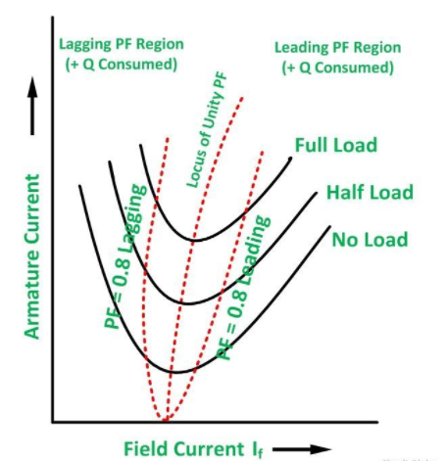

The curve connecting all the lowest points of all V-Curves for different power levels is called **Unity Power Factor Compounding Curve**. The compounding curves for 0.8 power factor lagging and 0.8 power factor leading are shown in the figure above by the red dotted line. The loci of power factor points on V-Curves are called **Compounding Curves**. It shows the manner in which the field current should be varied in order to maintain a constant power factor corresponds to the over excitation and leading current and under excitation and lagging current respectively.

* **TERMINAL VOLTAGE:**

The terminal voltage from the simulation is as follows:

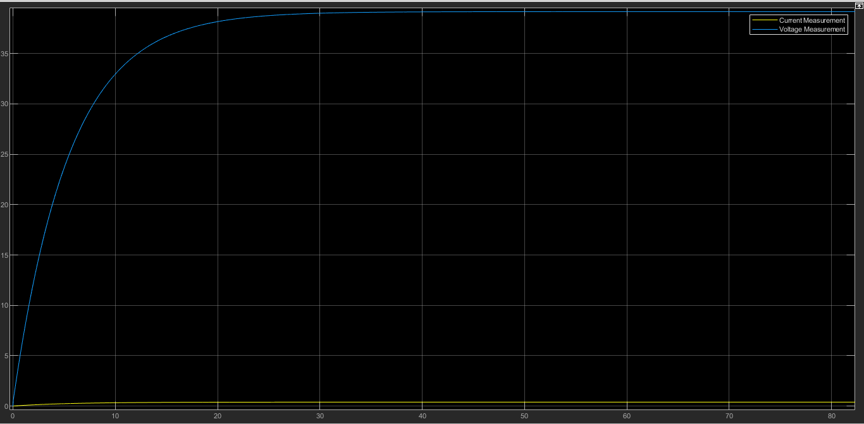

The voltage across the terminals is zero when the motor is starting so the voltage increases gradually, as the speed of motor increases the voltage also increases and when the synchronous motor reaches its maximum speed i.e. 1wm the potential difference also becomes maximum. As soon as the speed of motor becomes constant, the voltage also becomes a constant straight line parallel to X-Axis and perpendicular to Y-Axis at approx. 39 Volts. The blue line in the graph indicates the voltage across the terminals.

* STATOR CURRENT:

The stator current graph from the simulation is as follows:

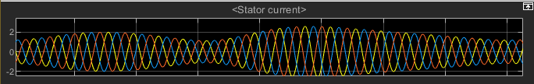

The stator current fluctuates from min i.e. 1,0,-1 and 2,0,-2 Amperes, to max i.e. 2.5,0,-2.5 Amperes. This fluctuation continues from min to max values synchronously.

* **OUTPUT TORQUE:**

The torque graph from the simulation is as follows:

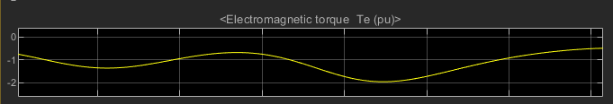

The torque value fluctuates between -0.8 to -1.3 Te and it also does decreases to -2 Te. This fluctuation continues throughout in a constant manner as this torque is produced by the synchronous motor.

* **SPEED:**

The simulation graph for motor speed is as follows:



(The speed is discussed in the 2nd section of this report “MOTOR SPEED”).

* **POWER FACTOR:**

Synchronous motors are designed to operate at 1.0 power factor or 0.8 power factor i.e. unity and leading power factor respectively. By varying the DC excitation of the motor, the power factor of the motor can be varied widely. Over excited synchronous motors operate at leading power factor and provide kVAR-like capacitors. This yields an improved power factor for the power supply system.

The speed of the DC generator, armature current, field current and electrical torque of DC generator is as follows:

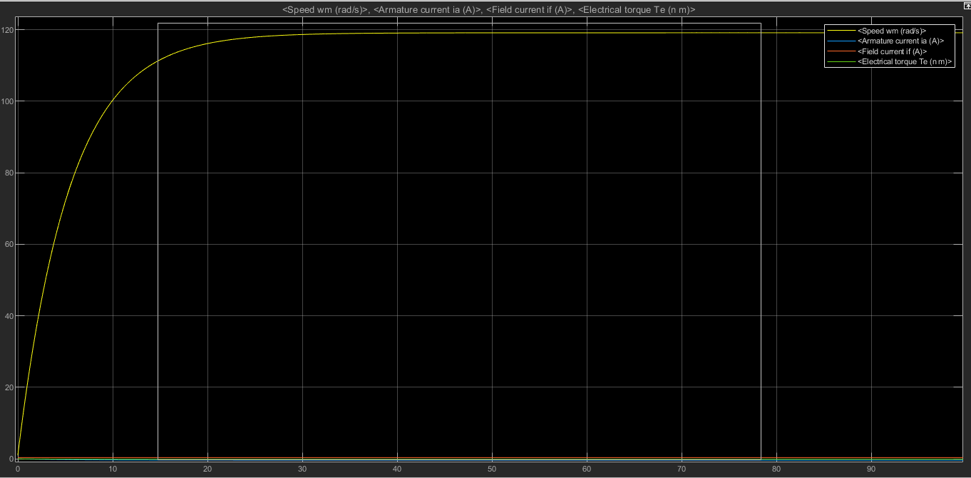

The graphs shows that the speed of rotor of DC generator increases with the rotor of synchronous motor and produces constant current, voltage and torque.

* **CONCLUSION:**

Synchronous motor is one of the most efficient motors. The ability to control their power factor makes it very demandable especially for low speed drives. An over excited synchronous-motor has leading power factor and is operated in parallel to induction motors thereby improving the system power factor. Speed remains constant irrespective of the loads in synchronous motors. This quality helps in industrial machines where constant speed is required irrespective of the load. Electro-magnetic power varies linearly with the voltage in synchronous motors. Synchronous motors usually operate with higher efficiencies (more than 90%) especially in low speed compared to induction motors.